# CS 255 System Design Document Template

This template lays out all the different sections that you need to complete for Project Two. Each section has guidance to prompt your thinking. You will need to continually reference the interview transcript as you work to make sure that you are addressing your client’s needs. There is no required length for the final document. Instead the goal is to complete each section based on what your client’s needs are. Remove this note when you are finished, and replace all bracketed text with the relevant information.

## UML Diagrams

### UML Use Case Diagram

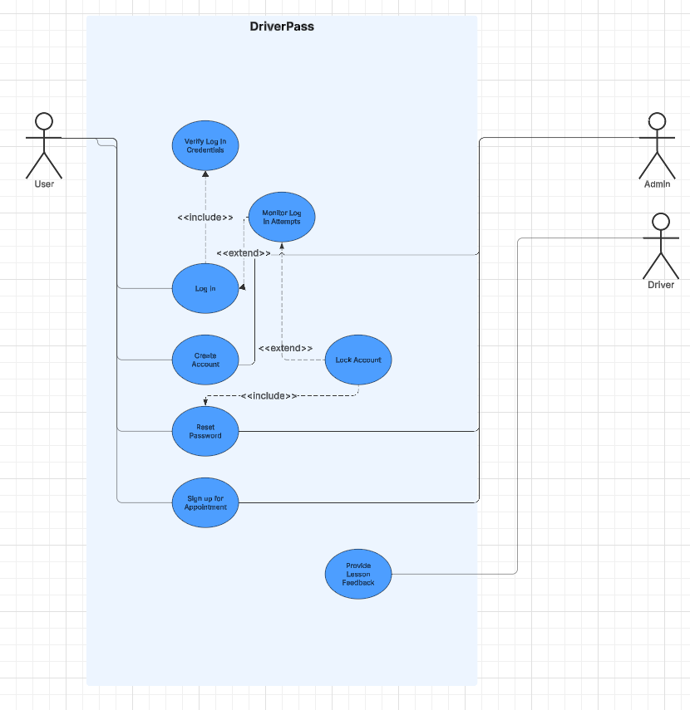

### UML Activity Diagrams

UML Activity Diagram for the use case of creating an account.

UML Activity Diagram for Reset Password Use Case

### UML Sequence Diagram

UML Sequence Diagram for Reset Password use case

### UML Class Diagram

## Technical Requirements

*[Based on the diagrams you have created, describe the technical requirements of your system. These requirements should address the required hardware, software, tools, and infrastructure necessary for your system design.]*

The DriverPass system will require a cloud architecture and databases from a 3rd party service. DriverPass will need computers and telephones at their office to access the cloud-based program as well as to receive phone calls from users.